

Student Names: Kamogelo Motau
Student Number: ST10500865
Module Code: PDAN8412
Description: Part 2
Date: 21 October 2026

Table of Contents
1. Executive summary 3
2. Dataset choice, quality and suitability 3
3. Analysis plan 3
4. Data preparation and EDA results 4
5. Feature selection 5
6. Logistic Regression from scratch 5
7. Training strategy and hyperparameter comparison 6
8. Final held-out test evaluation 6
9. Coefficient interpretation 7
10. Data quality and reproducibility limitations 7
11. Visual results and interpretation 8
Class balance: top-decile sales-rank proxy 8
Book price distribution 9
Title length by target class 9
Feature correlation matrix 10
Training loss over gradient-descent iterations 11
Scratch Logistic Regression coefficients 11
ROC curve on the test set 12
Precision–Recall curve on the test set 13
Held-out test confusion matrix 14
12. Conclusion and recommendations 14
13. References 16

1. Executive summary
In this research, the metadata of Amazon Books products is utilised to create a classifier based on binary Logistic Regression. PySpark is employed for huge-scale reading, cleaning, feature engineering, as well as data accumulation and exploratory data analysis (EDA). The Logistic Regression optimisation is executed from scratch using NumPy: sigmoid probabilities, binary cross-entropy, gradient computations, gradient decent updating, and L2 regularization. Scikit-learn is not involved in the model training process, but only in evaluation metrics calculation.
The objective of the model is to act as a proxy rather than a verified bestselling label; the books falling into the top 10% of the qualified Books sales-rank distribution are marked as 1, whereas the other ranked books are assigned 0. It is worth mentioning that lower Amazon sales-rank values indicate better sales performance.

2. Dataset choice, quality and suitability
Data-source: The source of the dataset is the McAuley Lab at the University of California, San Diego. The dataset page states that the source contains 2,370,585 records of Books product metadata. The source provides data such as title, price, description, category, sales rank, and related links.
Dataset landing page: https://mcauleylab.ucsd.edu/public_datasets/data/amazon/datasets.html
Direct file used by the notebook: https://snap.stanford.edu/data/amazon/productGraph/categoryFiles/meta_Books.json.gz
Justification: The dataset has more than 10,000 records, freely available in the public domain, comprises a field that contains sales rank that allows achieving the goal through reproducible binary proxy target and has enough of related metadata for numerical feature engineering. It is suitable for showing use of Spark processing for large datasets.
Quality considerations: It should be noted that this is an old Amazon snapshot that reaches back as far as July 2014, so prices, catalogue structure, or related item links should not be used as market conditions nowadays. It is important to note that some records do not contain valid rank or prices. The target component provides a comparison of sales ranks only for a given snapshot of this dataset, but it is not a certified number coming from a publisher or a New York Times bestsellers list.

3. Analysis plan
Stage | Planned action | Reason
EDA and cleaning | Inspect schema and counts; retain positive Books ranks and non-empty titles; quantify missing prices; cap positive prices at the 99th percentile; inspect distributions and class balance. | Check data validity, missingness, outliers and class imbalance before modelling.
Feature engineering / selection | Use price, title length, description length, category count, also-bought count, also-viewed count and a missing-price flag. Exclude ASIN, text, and sales rank from predictors. | Use interpretable numeric fields and avoid directly leaking the target-defining rank.
Split and scaling | Use a stratified 70% training, 15% validation and 15% test split. Estimate standardisation parameters from training data only. | Preserve class proportions and avoid using validation/test information to scale training data.
Model training | Implement sigmoid, binary cross-entropy, gradients and batch gradient descent with L2 regularisation in NumPy. | Meet the requirement to implement Logistic Regression from scratch.
Evaluation and retraining | Compare baseline and alternative learning-rate/regularisation settings using validation PR-AUC; choose threshold using validation F1; report final held-out test metrics. | Account for the minority positive class and reserve test data for final evaluation.
Reporting | Explain cleaning, EDA, target definition, model mechanics, metrics, limitations and reproducibility. | Make the results interpretable to the client and auditable by the marker.

4. Data preparation and EDA results
Processing stage | Stored notebook result
Raw Books metadata records (source page) | 2,370,585 products
Records with valid positive Books rank and non-empty title | 1,891,003
10th-percentile rank threshold | 282,778
Labelled records | 1,891,003
Class 0 before feature-level deduplication | 1,702,215
Class 1 before feature-level deduplication | 188,788
Duplicate feature/label rows reported | 501,094
Clean modelling rows after feature-level deduplication | 1,389,909
Final class 0 after feature-level deduplication | 1,208,213
Final class 1 after feature-level deduplication | 181,696
Modelling sample used by stored model outputs | 167,134 rows
Training / validation / test rows | 116,993 / 25,069 / 25,072

The available EDA includes a class-balance bar graph, a sampled price distribution, a title-length-by-class boxplot and a feature-correlation heat map. The positive price’s 99th percentile was equal to 150.05 (in source currency), which was established as a cap for prices to avoid the influence of outliers. Instead, around 26.47% of eligible records were proved to have non-positive or missing prices before imputation, at the same time a price_missing feature has been created.
As for the clean table used in modelling, its actual target prevalence after feature-level deduplication was equal to 13.07%. The same value for the modelling sample was close to 13.13%, which indicates that accuracy by itself cannot be considered enough. The stratified split conducted in the notebook preserved the positive-class occurrence rate close at 13.13% in all sets used for experiments.

5. Feature selection
Feature | Purpose / interpretation
price_clean | Positive price with extreme values capped; missing/non-positive prices are imputed.
title_length | Number of characters in the product title.
description_length | Number of characters in the description; missing descriptions become length zero.
category_count | Number of top-level category paths in the metadata.
also_bought_count | Number of linked products in the also-bought field.
also_viewed_count | Number of linked products in the also-viewed field.
price_missing | Indicator for missing or non-positive price before imputation.

The chosen fields were selected based on the criteria of availability and interpretability. Sales rank was not included among the predictors since it is the measure of target itself. Related-product counts might also be an indication of popularity based on the products that have been launched so far, so this model should be regarded as a retrospective classifier, rather than a causal predictor and a reliable pre-launch predictive mechanism.
The major limitation of the saved run is the fact category_count has zero standard deviation and its coefficient is equal to zero, which points at the lack of informational value of this particular feature in the context of the current feature selection process. Thus, this feature should be either revisited or dropped in further runs of the model.

6. Logistic Regression from scratch
The model starts by determining a linear score z = Xw + b for each record. The sigmoid function converts the calculated score to get the probability p = 1 / (1 + exp(-z)). Binary crosses entropy calculates the dissimilarity between observed label and predicted probability. Gradient for the weights is figured out using formula Xᵀ(p − y)/n with an addition of the L2 constraint λw. Bias gradient is determined by averaging (p − y). Each epoch results in the weights and bias being adjusted accordingly to minimize the loss.
As for the implementation, sigmoid inputs and predicted probabilities are clipped for numerical stability. Standardization is done based on the means and standard deviations of the training set only.

7. Training strategy and hyperparameter comparison
Model | Learning rate | Epochs | L2 | Validation accuracy | Precision | Recall | F1 | ROC-AUC | PR-AUC
Baseline | 0.05 | 800 | 0.01 | 0.888508 | 0.585223 | 0.517472 | 0.549266 | 0.871313 | 0.522667
Tuned | 0.02 | 1200 | 0.10 | 0.868762 | 0.666667 | 0.000608 | 0.001214 | 0.869611 | 0.520098

In comparison to the baseline, the alternative model features a slightly lower validation PR-AUC value (0.520098). At the same time, its recall for the 0.5 threshold is close to zero which leads to the conclusion that the baseline model is selected according to the validation PR-AUC. It is a correct decision because PR-AUC is useful for the case when the positive class is rare.
The threshold selected for the validation process was 0.25 that corresponds to 0.564465 of F1 score. After this step, the threshold was fixed for final test evaluation.

8. Final held-out test evaluation
Metric | Stored test result | Interpretation
Decision threshold | 0.25 | Selected on validation data, not on the test set.
Accuracy | 0.870932 | 87.09% of all test records were classified correctly.
Precision (positive class) | 0.506641 | About 50.66% of predicted top-decile books were actually in the proxy-positive class.
Recall (positive class) | 0.648846 | The model identified about 64.88% of actual proxy-positive books.
F1-score (positive class) | 0.568993 | Balances positive-class precision and recall.
ROC-AUC | 0.874467 | Indicates useful ranking discrimination across thresholds.
PR-AUC / average precision | 0.531852 | Summarises positive-class precision/recall performance; compare with the positive prevalence of about 0.131.

As per the test classification report, class-1 has the precision of 0.51, recall of 0.65 and F1 of 0.57 out of total 3,292 positive test cases. In terms of class-0, the model has obtained precision of 0.94, recall of 0.90 and an F1 of 0.92 out of a total of 21,780 cases. The total accuracy of the model is around 0.87.
As for the baseline models, majority class model has been able to achieve the accuracy of 0.868698 and positive class recall of zero. The model’s accuracy is slightly more than that of the majority class model but the PR-AUC and positive recall rate of the model provide much better information for the problem outcome.

9. Coefficient interpretation
Feature | Standardised coefficient
also_bought_count | 1.103865
title_length | 0.115483
price_missing | -0.111353
description_length | 0.034881
price_clean | -0.015643
also_viewed_count | 0.013339
category_count | 0.000000

The coefficient with the highest absolute value is also_bought_count (positive), meaning that when we hold all of the other standardised predictors constant, its higher value will lead to higher model log-odds of being in the top-decile rank group. However, this must not be interpreted as evidence that links between related products cause sales: the data are observational, the variable may reflect existing popularity, and the coefficient is specific to the features used in the analysis.

10. Data quality and reproducibility limitations
The notebook that has been restored records 501,094 instances of replicated engineered features/label lines and eliminates the redundancy at the level of engineered features/label pair. It may thus merge different books sharing the same engineered values. The corrected notebook provides documentation of the problem and retains the previously computed metrics instead of silently replacing them with new values. For final evaluation, it will be necessary to keep ASIN through feature engineering, deduplicate by ASIN, rerun the whole strategy, and replace all tables and figures with the results obtained from this run.
One defect in the cell order was fixed as well. Namely, one cell used sample_pd before it was defined, whereas the corrected version of the cell analyses the created Spark feature table instead..
There are limitations such as old data snapshots, the use of the proxy instead of actual bestseller labels, the absence of price values, the risk of information leaking from related product links, limited features, and the use of a batch gradient descent learning model instead of a distributed Spark ML estimator. The instruction of the task notes that Spark is needed for analysis but it does not have to be used for model training.
The source files used in the current notebook are present in a relative path. Hence, place meta_Books.json.gz into the same folder as the notebook, read the required security files from requirements.txt and record the date of the model training and environment download in the final report.

11. Visual results and interpretation

Class balance: top-decile sales-rank proxy
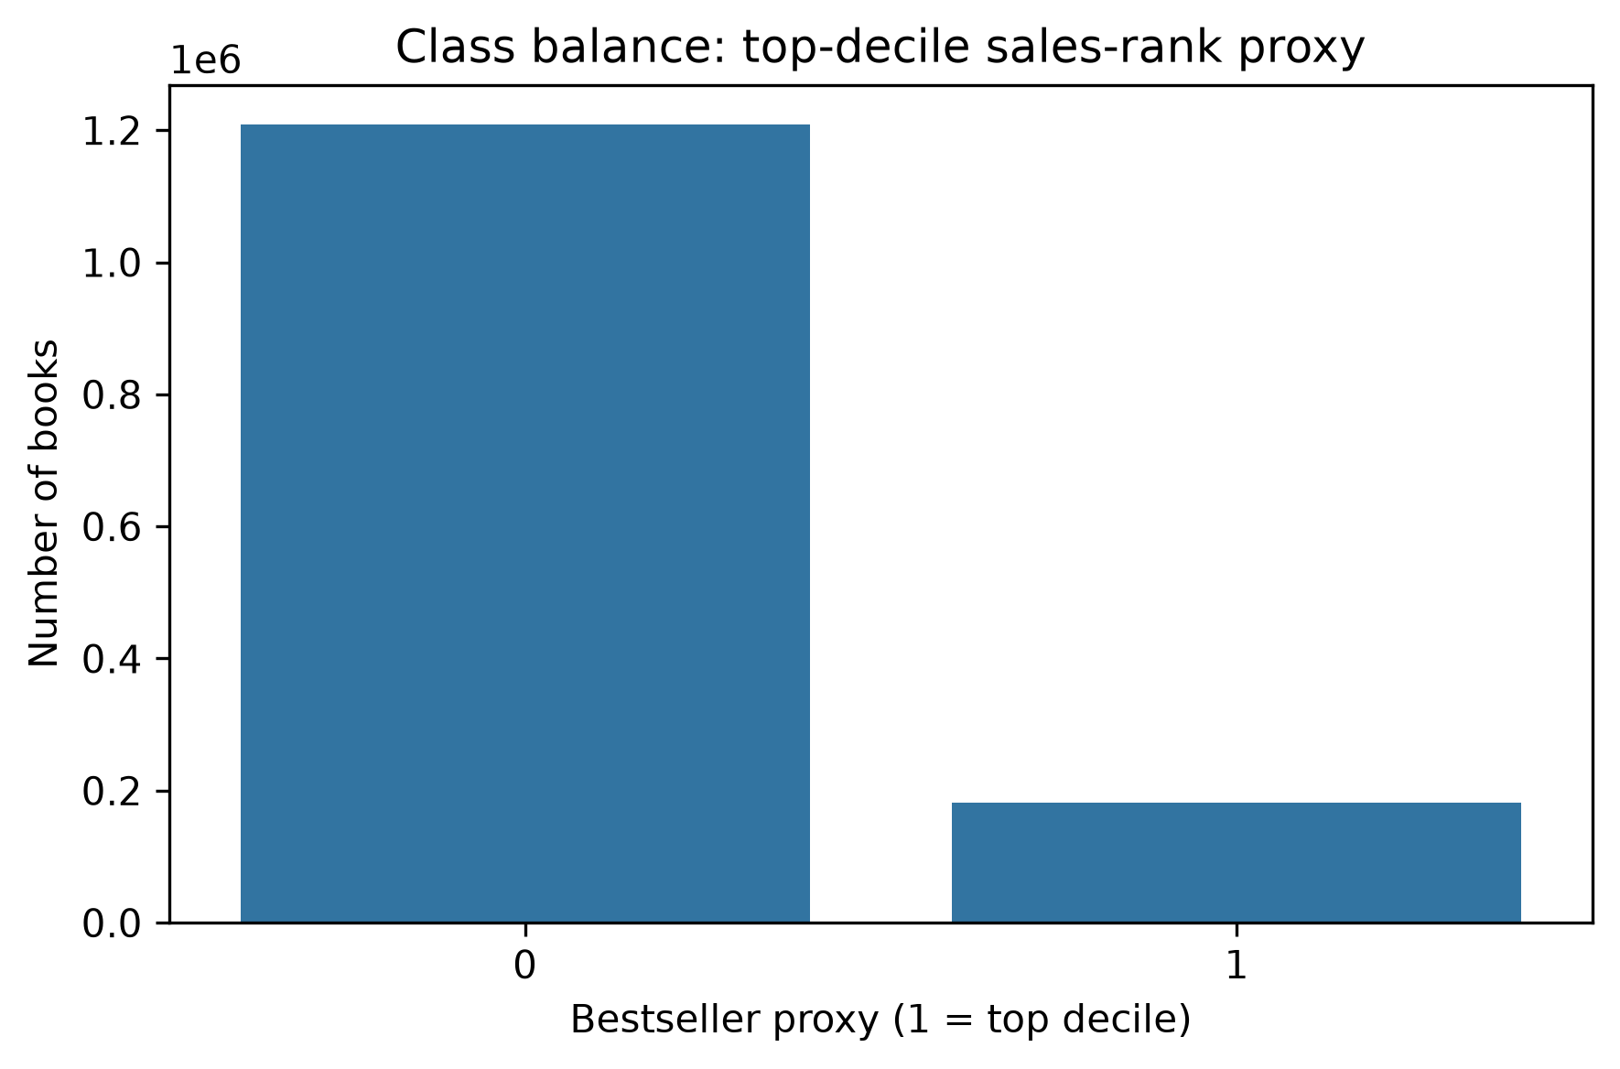
Interpretation: The positive class is significantly less than the negative class. The number of instances counts around 1.21 million of non-top-decile books and 0.18 million of top-decile books in the analysed clean data. This imbalance results in a high accuracy of classifiers that only predict belonging to class 0. Thus, besides accuracy, precision, recall, F1-score, and precision-recall AUC should be considered.

Book price distribution
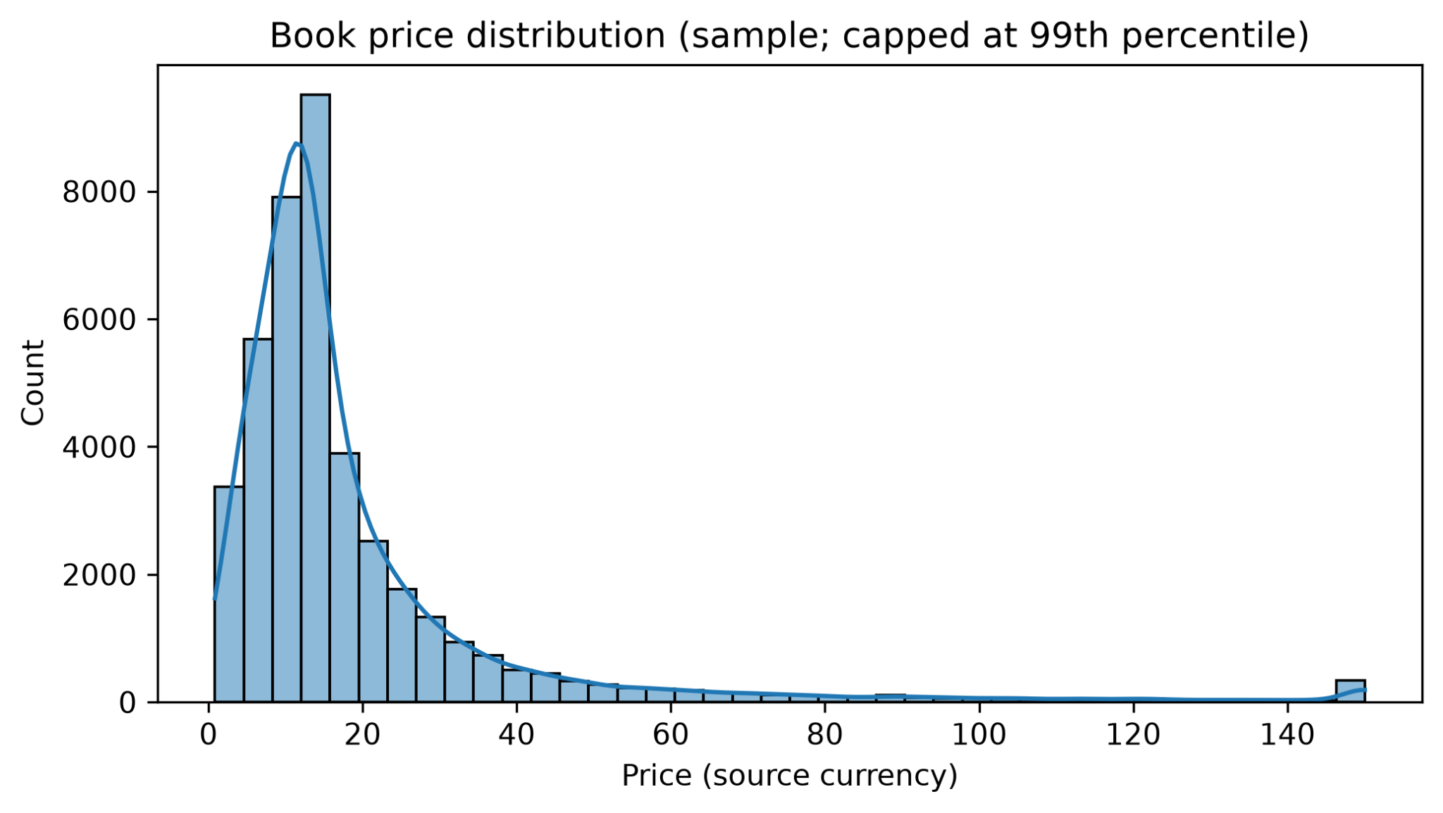
Interpretation: The price distribution is heavily skewed to the right. The bulk of the prices collected in our sample is found at the lower end of the spectrum together with a small number of high-value prices, which leaves a long tail. Visualization of the graph stops at the 99th percentile and does not imply that prices with extreme values are, in fact, incorrect, which is demonstrated in this notebook with 150.05 in the source currency as its current cap and used in tandem with a missing-price indicator allowing to preserve missing or incorrect prices.

Title length by target class
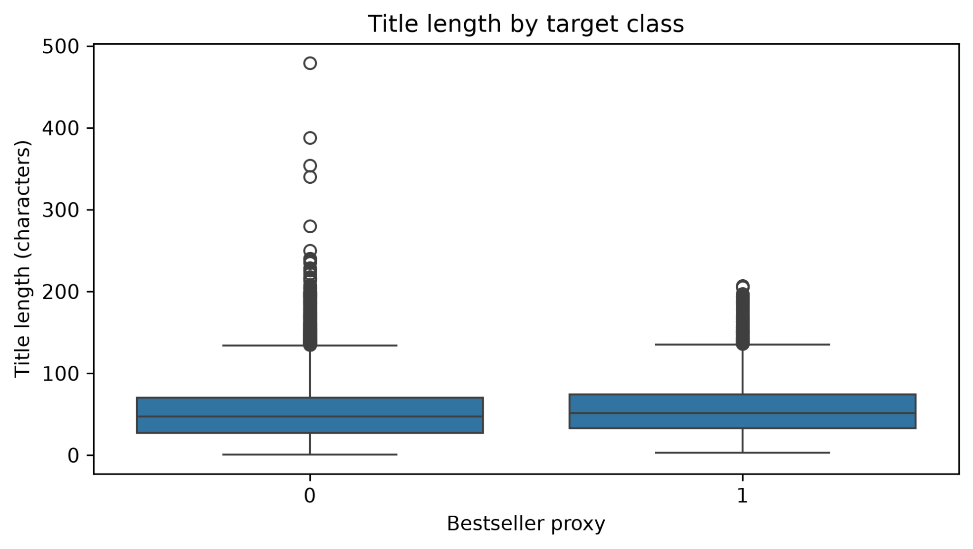
Interpretation: The title-length distributions of the two classes overlap to a large extent. The class formed by the top decile seems to have a somewhat high title length median, but in comparison with the variation of title length in both classes as a whole, the difference tends to become small. There are multiple cases of long titles occurring in both classes, so title length will not be a strong discriminator of the classes, and identifying the cases should be based on the examination of metadata rather than mere removal.

Feature correlation matrix
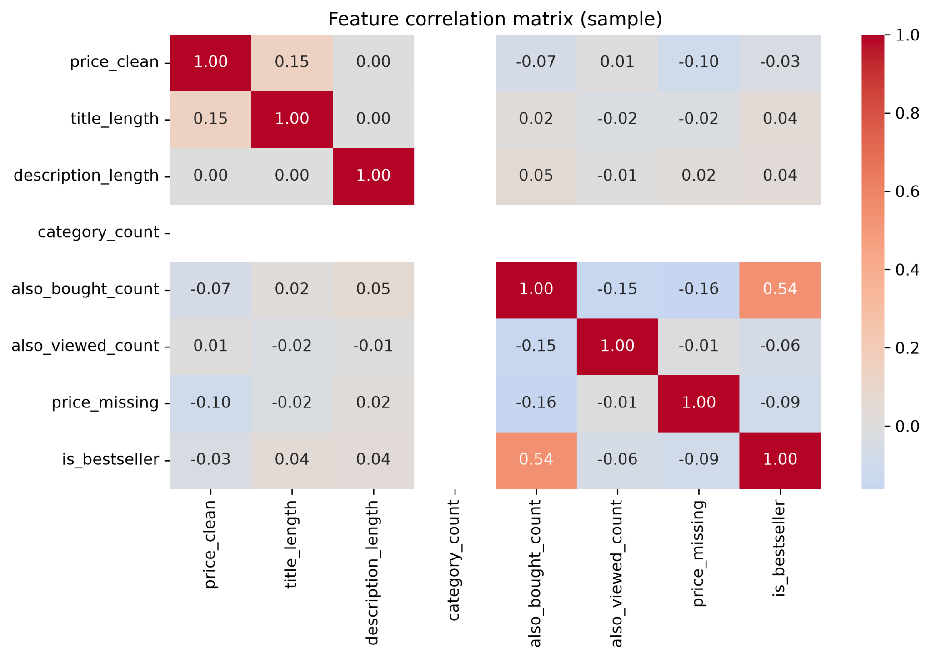
Interpretation: The strongest correlation with the target variable is found in the positive relationship between also_bought_count and is_bestseller, which is approximately equal to 0.54. Other correlations listed are negligible with respect to the zero value, i.e. title_length and description_length are about 0.04, price is around –0.03, also_viewed_count is approximately equal to –0.06 and price_missing is about –0.09. Note that none of these correlations imply causation. Empty cells in the count_category row/column means no correlation was found for this constant variable in the data taken for analysis due to constant variable behavior in this experiment.

Training loss over gradient-descent iterations
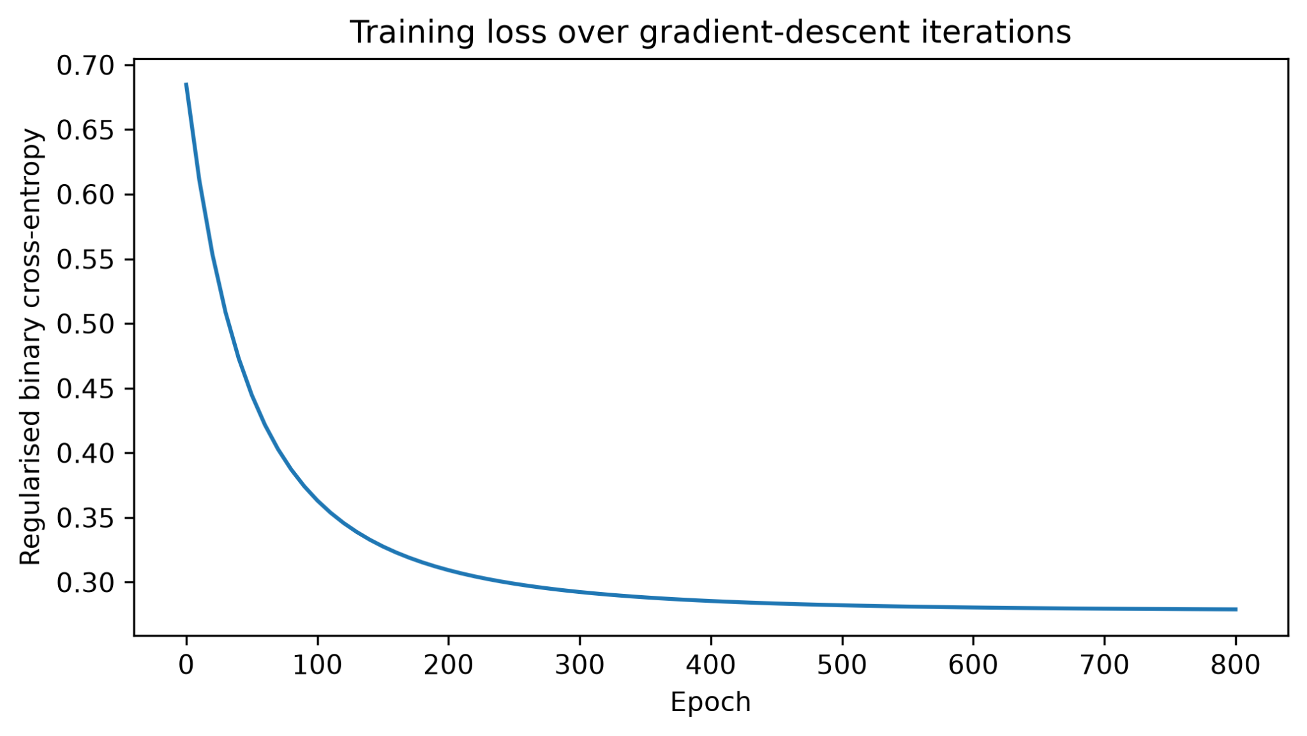
Interpretation: Regularized binary cross-entropy starts at a high value of approximately 0.685 and quickly falls below 0.4 before approximately the first 100 epochs are completed. After that, it decreases progressively and settles at about 0.28 by epoch 800. This follows a smooth training-loss trajectory, but this in itself does not imply generalization, since validation metrics and the hold-out test set are still required.

Scratch Logistic Regression coefficients
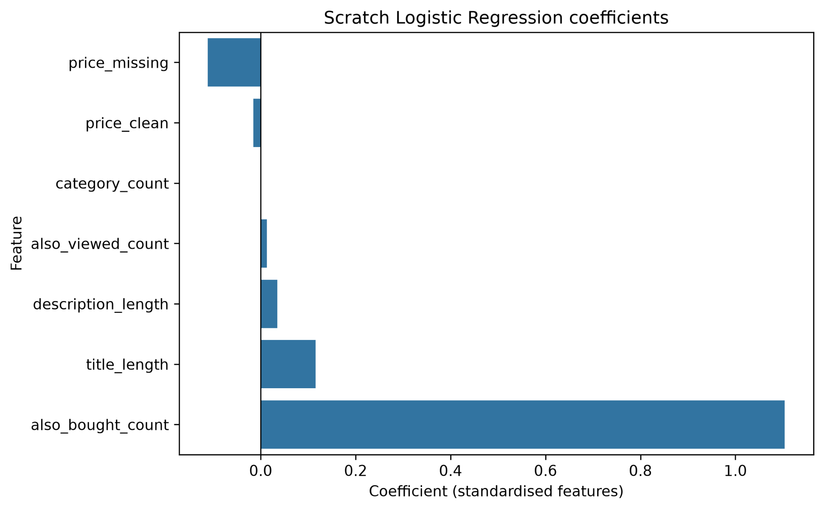
Interpretation: Among all of the features, also_bought_count has the biggest positive standardized coefficient. Increase in also_bought_count leads to increase in the predicted log-odds of receiving a top-ten rank in sales, keeping other features constant. title_length and description_length have smaller positive coefficients, while also_viewed_count is slightly positive. price_clean and price_missing target negative coefficient values. coefficient of category_count is practically zero. Coefficients reflect existing associations rather than causal relationships in the specified model. Also, strong signal from related products may reflect popularity importance that is already present in the catalogue..

ROC curve on the test set
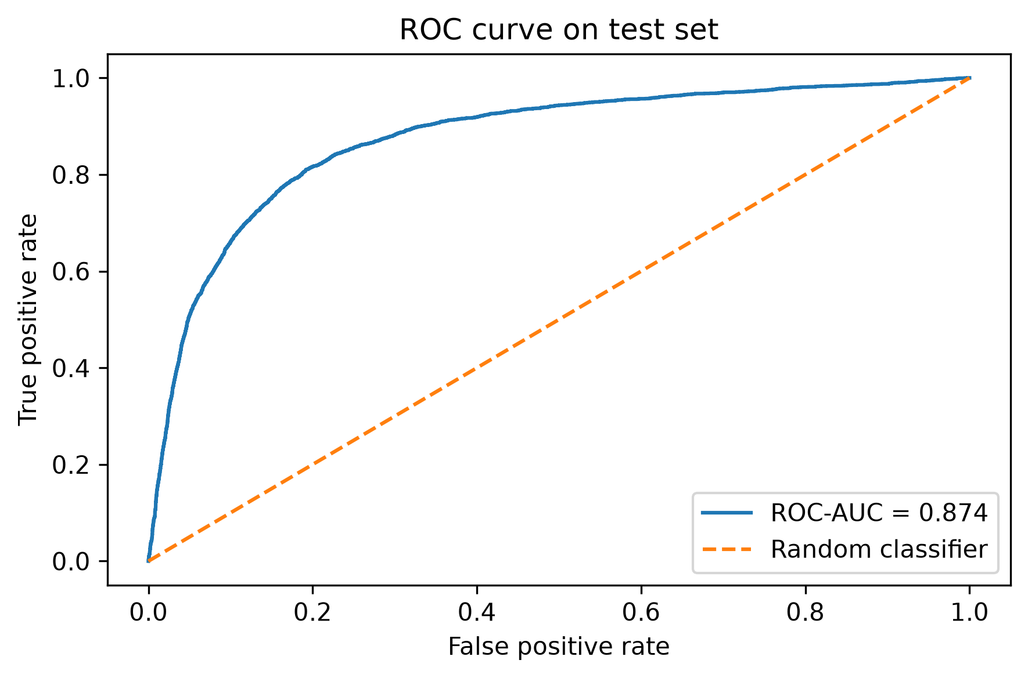
Interpretation: The recorded ROC-AUC is 0.874, which symbolizes that ranking can be distinguished quite well i. e. a random positive case is usually assigned higher ratings than a random negative one. The slope of the curve is considerably higher than that of the randomly classifying model curve. The ROC-AUC indicates ranking across thresholds but with no guarantee that high precision is achieved at the needed operating threshold.

Precision–Recall curve on the test set
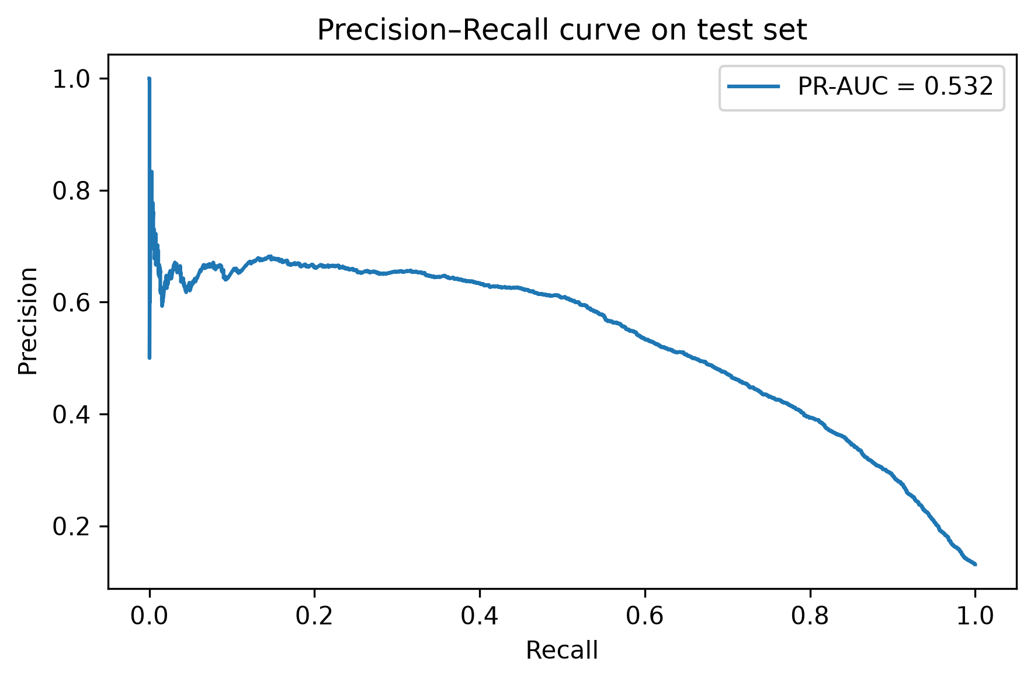
Interpretation: The PR-AUC that was obtained is close to 0.532. Precision varies from 0.6 to 0.7 for low and medium recall but drops to zero when the recall equals to 1.0 indicating that the process is conflicting in terms of searching for potential bestsellers by increasing the false positive cases. Since the number of the positive cases is low, the precision-recall curve is quite informative. The baseline precision is equal to the positive class incidence, which is around 0.13; thus, the reached PR-AUC score may be considered quite good.

Held-out test confusion matrix
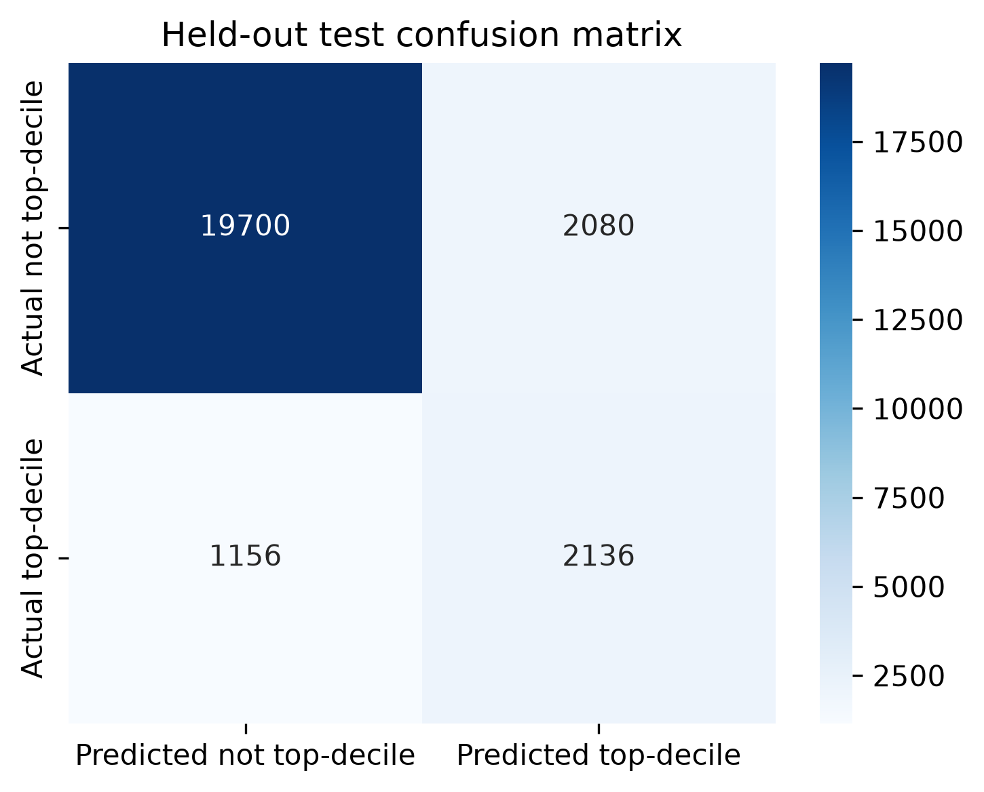
Interpretation: The matrix has 19,700 true negatives, 2,080 false positives, 1,156 false negatives, and 2,136 true positives at this threshold. Therefore, the model is able to find 2,136 out of 3,292 real positive cases giving a recall rate of 64.9% but the number of alleged positives in this model is equal to 2,080. The precision of the model is equal to 50.7%. Therefore, in a publishing house, this threshold will help identify about two-thirds of best-sellers but will also need to review many of them.

12. Conclusion and recommendations
The analysis shows the entire process of working with PySpark for large-scale data preparation and exploratory data analysis (EDA) along with the implementation of logistic regression from the beginning using NumPy. In the last executed run, the non-tuned model was more successful than its modified version according to the validation PR-AUC, achieving the test ROC-AUC of 0.874, the PR-AUC score of 0.532, the precision of 0.507, and the recall of 0.649 with the threshold obtained through validation equal to 0.25. This means that the model works quite well for separating the proxy-positive class, although some false positive results still appear.
Before treating the work as complete, rerun the corrected notebook from top to bottom, and think about applying the deduplication by ASIN instead of performing it according to created feature/label values in the final version of the report.

13. References
McAuley, J., Targett, C., Shi, J. and van den Hengel, A. (2015). Image-based recommendations on styles and substitutes. Proceedings of the 38th International ACM SIGIR Conference on Research and Development in Information Retrieval.
McAuley Lab (n.d.). Amazon product data: metadata and reviews. University of California San Diego. Available at: https://mcauleylab.ucsd.edu/public_datasets/data/amazon/datasets.html (Accessed: 20 October 2026).
McAuley Lab (n.d.). Amazon Books metadata file, meta_Books.json.gz. Available at: https://snap.stanford.edu/data/amazon/productGraph/categoryFiles/meta_Books.json.gz (Accessed: 20 October 2026).
scikit-learn developers (n.d.). Metrics and scoring: quantifying the quality of predictions. Available at: https://scikit-learn.org/stable/modules/model_evaluation.html (Accessed: 20 October 2026).

